**Fresher Super Market in Bangladesh**

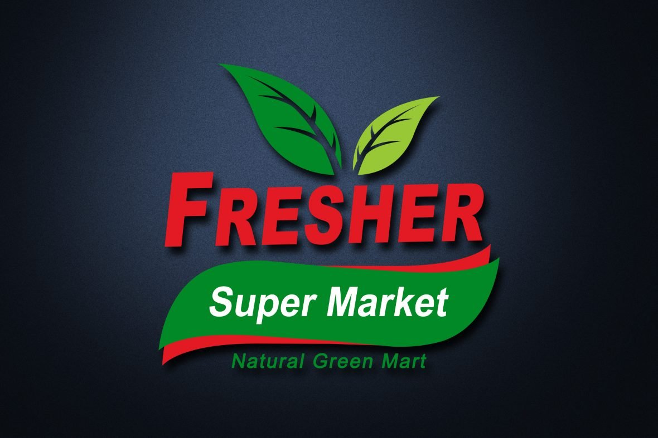

**What is Super Market?**

A supermarket is a large retail store that sells a wide variety of goods, primarily focused on food and household items. Supermarkets are organized into sections or aisles for different product categories, such as:

* **Grocery items:** Grains, cereals, canned goods, and packaged foods.
* **Fresh produce:** Fruits and vegetables.
* **Meat and seafood**: Fresh, frozen, and packaged options.
* **Dairy products:** Milk, cheese, yogurt, and eggs.
* **Bakery items:** Bread, pastries, and cakes.
* **Frozen foods:** Ready-to-eat meals, frozen vegetables, and ice cream.
* **Beverages:** Water, soda, juices, tea, and alcoholic drinks.
* **Household goods:** Cleaning supplies, paper products, and personal care items.

**Super Market in Bangladesh**

Supermarkets in Bangladesh have become an integral part of urban life, particularly in major cities like Dhaka, Chittagong, Sylhet, and Khulna. The rise of supermarkets reflects changing consumer lifestyles, increased purchasing power, and a growing demand for convenience and variety.

**Market Ratio**

**Key Features of Supermarkets in Bangladesh:**

* **Convenience and Variety:**

Supermarkets offer a wide range of products under one roof, including groceries, fresh produce, meats, dairy, packaged goods, household items, and more. This convenience has made them increasingly popular.

* **Urban and Semi-Urban Presence:**

While most supermarkets are located in urban centers, there is a gradual expansion into semi-urban and peri-urban areas as infrastructure improves and demand grows.

* **Focus on Quality and Hygiene:**

Supermarkets often emphasize quality, proper storage, and hygienic handling of food and other items. This appeals to middle- and upper-middle-class consumers.

* **Modern Retail Trends:**

Many supermarkets incorporate modern retail trends, such as loyalty programs, home delivery services, and online shopping options.

**Fresher Super Market in Bangladesh**

Fresher supermarkets in Bangladesh focus on offering hygienically packaged goods, fresh produce, dairy products, meats, and imported items under one roof. Many of these stores target busy professionals and families who value convenience, quality, and a clean shopping environment.

**Growth Potential:**

The Fresher supermarket in Bangladesh driven by a young population, increasing urbanization, and rising disposable income. The shift toward e-commerce and online grocery shopping has also opened new avenues for growth, with platforms and becoming increasingly popular.

**Future Trends:**

* Growth in online grocery delivery services.
* Expansion of supermarket chains into smaller cities and towns.
* Increasing focus on sustainability and organic products.
* Adoption of digital payment systems and app-based loyalty programs.

**Structure of ‘Fresher Super Market’**

**Selfcare product**

**Groceries**

**Cleaning Supplies**

**Dairy**

**Fruits**

**Bakery**

**Cash Counter**

**Meat**

**Result & Account**



**Challenges for Fresher Supermarkets**

1. **Competition with Traditional Markets:**

Despite their growth, supermarkets face stiff competition from traditional wet markets (bazars) and small neighborhood stores due to their affordability and accessibility.

1. **Supply Chain Issues:**

Efficient supply chain management remains a challenge, especially for perishable goods.

1. **High Operating Costs:**

Maintaining quality, staffing, and modern infrastructure can be expensive, affecting profitability.

1. **Consumer Behavior:**

Many consumers still prefer bargaining and shopping at traditional markets, which offer a more personalized experience.